**CSS Position**

Syntax - selector {position: type}

Type of positioning method -: Static, Relative, Absolute, Inherit, Sticky.

1. Static -
   1. HTML Elements are by default static.
   2. Static positioned elements are not affected by top, bottom, left, right properties.
   3. An element with position : static is positioned according to the flow of document.
2. Relative –
   1. An element with position : relative; is positioned relative to its normal position.
   2. Setting the top, right, bottom, and left properties of a relatively-positioned element will cause it to be adjusted away from its normal position. Other content will not be adjusted to fit into any gap left by the element.
3. Fixed –
   1. An element with position : fixed; is positioned relative to the viewport, which means it always stays in the same place even if the page is scrolled. The top, right, bottom, and left properties are used to position the element.
   2. A fixed element does not leave a gap in the page where it would normally have been located.
4. Absolute –
   1. An element with position : absolute; is positioned relative to the nearest positioned ancestor (instead of positioned relative to the viewport, like fixed).
   2. However; if an absolute positioned element has no positioned ancestors, it uses the document body, and moves along with page scrolling.
   3. **Note:** A "positioned" element is one whose position is anything except static.
5. Sticky –
   1. An element with position: sticky; is positioned based on the user's scroll position.
   2. A sticky element toggles between relative and fixed, depending on the scroll position. It is positioned relative until a given offset position is met in the viewport - then it "sticks" in place (like position: fixed).
   3. **Note:**Internet Explorer, Edge 15 and earlier versions do not support sticky positioning. Safari requires a -webkit- prefix (see example below). You must also specify at least one of top, right, bottom or left for sticky positioning to work.

**Overlapping Elements –**

1. When elements are positioned, they can overlap other elements.
2. The z-index property specifies the stack order of an element (**which element should be placed in front of, or behind, the others**).
3. An element can have a positive or negative stack order:
4. Ex - 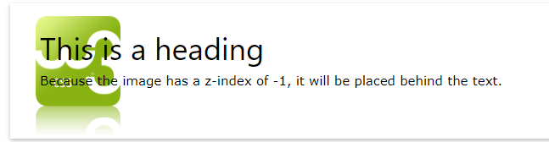
5. An element with greater stack order is always in front of an element with a lower stack order.
6. **Note:** If two positioned elements overlap without a z-index specified, the element positioned last in the HTML code will be shown on top.

**Positioning text in an Image** – ref to w3schools.

Note: Please visit below link for examples.

Reference – https://www.w3schools.com/css/css_positioning.asp